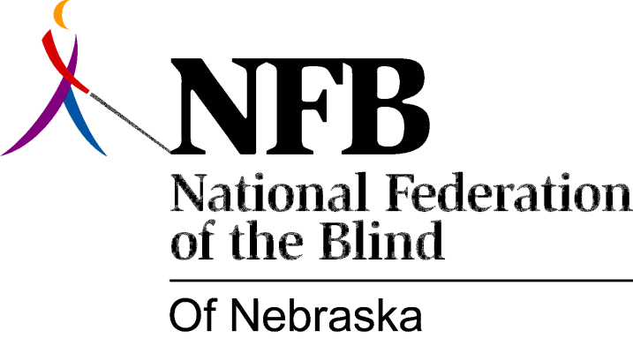

Resolution 1972 - 02
Re: Informing the Public

We resolve that the President of the National Federation of the Blind of Nebraska, be charged with and authorized to have the necessary funds at his disposal for the purpose of informing the general public, through any communication media that deems necessary or productive to accomplish this goal.

