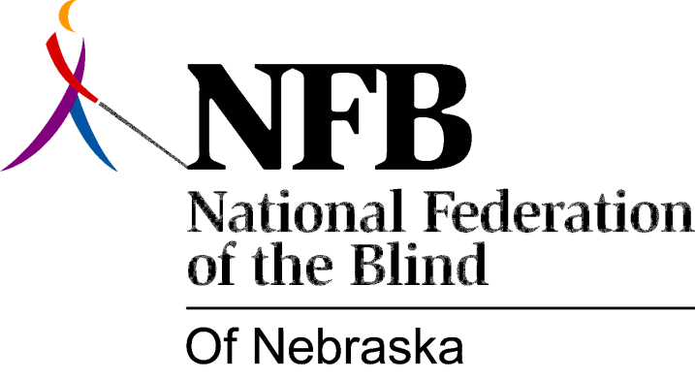

Resolution 1972 - 03
Re: Concern over the Philosophy of Nebraska Services for the Visually Impaired

Whereas, the present philosophy of the Services for the Visually Impaired of Nebraska has been inconsistent, uncooperative, discriminatory and, apathetic towards the clients they are serving,

In view of these facts we, as a blind organization, feel that this is a reflection of the past and present leadership of the Services for the Visually Impaired.

We contend that if the present philosophy persists in this manner towards the clients of the Services for the Visually Impaired, we recommend as an organized body that such philosophy and leadership should be changed.

