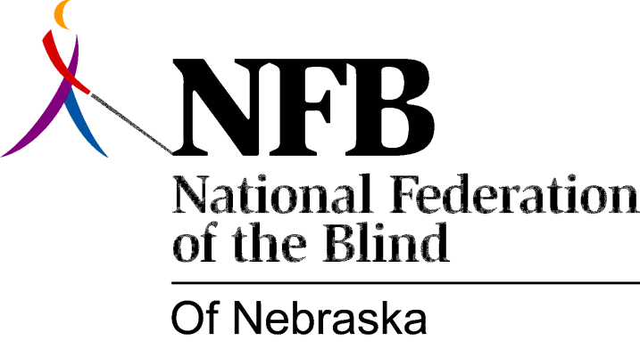

Resolution 1974 - 04
Re: Appointment of James Nyman as Director of Nebraska Services for the Visually Impaired

We the National Federation of the Blind of Nebraska in convention assembled this 18th day of May 1974 in the city of Lincoln do here by: approve and applaud the decision leading to the naming of a new director of the Vocational Rehabilitation State Services for the Visually Impaired, and,

whereas, the naming of a new director will do much to improve the relationship between not only the blind and visually impaired and the State Services for the Visually Impaired but will also vastly improve the relationship between the State Services for the Visually Impaired and the Lions Clubs, Nebraska Foundation for the Visually Handicapped, Counsel of Jewish Women, and other such organizations chartered to provide aid and assistance to the blind and visually impaired, and,

whereas, the attitude and philosophy of the new director Dr. James Nyman is one of truly rehabilitating the blind so that they might participate fully in the job market and in fact all phases of full community participation. A philosophy which believes as we of the National Federation of the Blind of Nebraska believe that blindness is neither a form of dying nor a disaster but rather given proper training and opportunity blindness can be reduced to a physical nuisance.

Therefor be it resolved, that the President and State Officers be instructed to provide a copy of this resolution to the Governor and Director of Department of Institutions and all Nebraska State Senators so that they might knew that we the largest group of organized blind in the state do here by support fully the naming of the new director.

