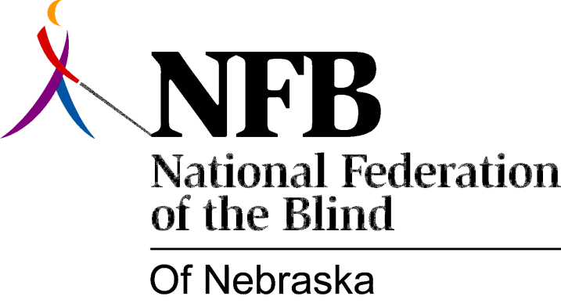

Resolution 1976 – 03
Re: Administration of the Library for the Blind and Physically Handicapped

WHEREAS, in the 1976 session of the Unicameral, Senator Gerald Cook introduced, on behalf of the national Federation of the Blind of Nebraska, L.B. 661, a bill that would have transferred the Administration of the Library for the Blind and Physically Handicapped from the Nebraska Library Commission to the Division of rehabilitation Services for the Visually Impaired, and,

WHEREAS, this legislation was not only supported by the national Federation of the Blind of Nebraska, but by all other consumer groups of the Blind in Nebraska, as well as a group of parents of visually impaired children and some organizations of the physically handicapped, and,

WHEREAS, this type of legislation is needed to improve library services to consumers, and would also enable more federal funds to be channeled into services for the blind and physically handicapped, now, therefore,

BE IT RESOLVED, by the National Federation of the Blind of Nebraska, in convention assembled this 15th day of May, 1976, in the city of Grand Island, Nebraska, that the president and all officers and appointees of the president shall be introduced to work closely with Senator Gerald Cook as well as any and all members of the Unicameral to reintroduce, in the 1977 session of the Unicameral such legislation as will bring about these positive changes in improving library services for the blind and physically handicapped in Nebraska.

This Resolution Passed Unanimously

