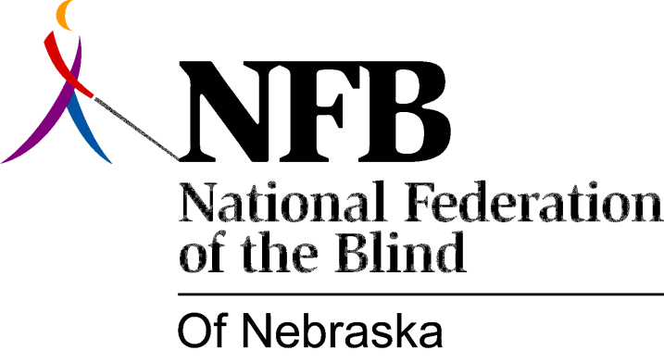

Resolution 1976 – 04
Re: Misuse of information by the Nebraska Library for the Blind and Physically Handicapped

WHEREAS, it is obvious to all those concerned with library services to the blind and physically handicapped within Nebraska, that over the past few months, there has been illegal use of the franking privilege as well as the consumer mailing list, and ,

WHEREAS, the Library for the Blind and Physically Handicapped under the apparent direction of Miss Jane Geske, Executive Director, Nebraska Library Commission, has chosen to place the library in the censorship role, and further, in a non-cooperative position toward referral of the Library Commission to the Rehabilitation for the Blind Agency, and,

WHEREAS, there has been much correspondence between the National Federation of the Blind of Nebraska and the Library of Congress, Division for the Blind and Physically handicapped in regard to these and other related problems, and,

WHEREAS, there has been no solution to these and other related problems forthcoming, from either the general council of the Library of Congress, Division for the Blind and Physically Handicapped, Mr. Frank Sylke, now, therefore,

BE IT RESOLVED, by the National Federation of the Blind of Nebraska, In convention assembled this 15th day of May, 1976, in the city of Grand Island, Nebraska, that the president and, all officers, as well as all members of the national Federation of the Blind of Nebraska be instructed to bring whatever force and attention is necessary to resolve this situation in a positive manner, and,

BE IT FURTHER RESOLVED, that until there have been positive steps taken by the chief of the Division for the Blind and Physically handicapped of the Library of Congress to correct this situation, that all members of the National Federation of the Blind of Nebraska be urged to write and call both the members of the Senate and, the house or Representatives as well, in regard to this matter.

This Resolution Passed Unanimously.

