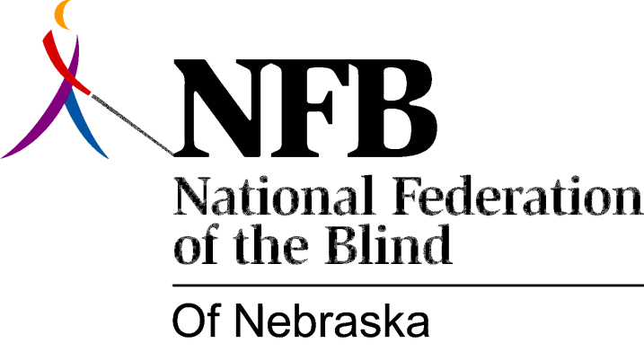

Resolution 1977-02
Re: Commendation of the Legislature and Governor for securing the Right of the Blind to a Secret Ballot.

WHERAS, The National Federation of the Blind of Nebraska passed Resolution 76-11 in convention assembled in the city of Grand Island, Nebraska to propose legislation to eliminate the requirement that "The Person Rendering Assistance (To A Blind or Disabled Elector) must be a registered voter in the State of Nebraska"; AND

WHERAS, Senator Harold Moylan did introduce such legislation to guarantee the right of free choice to the blind voter in the selection of the person assisting him; AND

WHEREAS, Such legislation was included in legislative bill 201 and was passed by the 85th Legislature of the State of Nebraska and was signed into law by Governor J. James Exon; AND

WHERAS, The National Federation of the Blind of Nebraska believes that this act removes yet one more barrier to the complete integration of the blind THEREFORE,

BE IT RESOLVED by the National Federation of the Blind of Nebraska in Convention assembled this 14th day of May, 1977, in the city of Lincoln, Nebraska that this organization applauds and commends this action by the legislature and the governor which recognizes the inherent right of blind persons to participate in society as full and equal citizens; AND,

BE IT FURTHER RESOLVED, that the secretary of this organization be instructed to send copies of the resolution to senator Moylan, Introducer of the Legislation, all other members of the Unicameral, the Clerk of the legislature, and Governor J. James Exon.

Passed Unanimously May 14th, 1977

