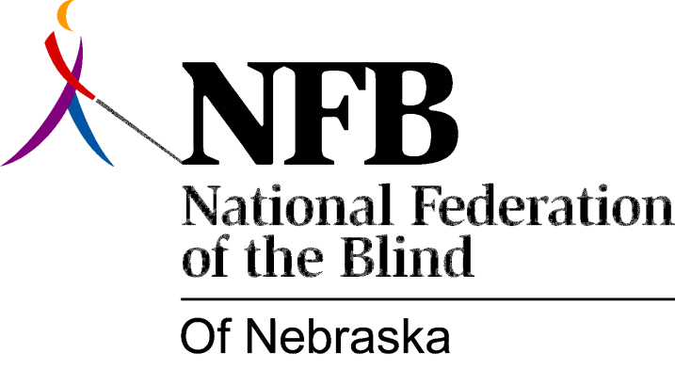

RESOLUTION 1977-10
RE: Instruction to the Legislative Committee to Study "Little Randolph-Sheppard Acts."

WHEREAS, The National Federation of the Blind of Nebraska is vitally concerned with employment opportunities for Blind persons; and,

WHEREAS, Small Business Enterprises can offer such opportunities to blind persons in the state of Nebraska; AND,

WHEREAS, There exists a definite Need to Expand this program Beyond the Provision of the RANDOLPH-SHEPPARD Act; AND,

WHEREAS, Such expansion has been achieved by the passage of little "RANDOLPH-SHEPPARD ACTS" in other states; NOW, THEREFORE,

BE IT RESOLVED, by the National Federation of the Blind of Nebraska in Convention Assembled this 15th Day of May, 1977, in the city of Lincoln, Nebraska that the legislative committee of this organization be instructed to study the "Little Randoolph-Sheppard Acts" of other states and report its findings to the Board of Directors of this organization for their examination and recommendations concerning possible legislative actions; AND,

BE IT FURTHER RESOLVED, That the Secretary of this Organization be instructed to send copies of this resolution to the Director of Nebraska rehabilitation services for the Visually Impaired and the President of Business Enterprise Vendors of Nebraska.

Passed by Majority Vote May 15, 1977

