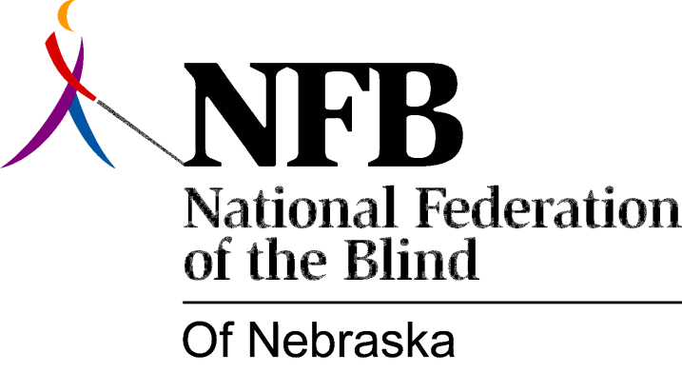

Resolution 1978 – 01
Re: Commendation of Forrest ("Frosty") Chapman

WHEREAS, the 1976 convention of the National Federation of the Blind of Nebraska passed a resolution establishing an employment committee to study the status of employment of blind persons, and

WHEREAS, one goal of the committee was to work for the elimination of the question concerning disability on State employment application forms and

WHEREAS, the National Federation of the Blind of Nebraska made its views known at the 1977 state convention concerning this matter and

WHEREAS, Forrest ("Frosty") Chapman of the State Department of Personnel expressed a willingness to work with this organization and

WHEREAS, Forrest Chapman persuaded the State Department of Personnel and other State agencies to eliminate the question of physical impairment from the State employment application form, and

WHEREAS, the memorandum announcing the change credited the National Federation of the Blind of Nebraska, for its views on this subject, now, therefore

BE IT RESOLVED, by the National Federation of the Blind of Nebraska, in convention assembled this 17th day of June, 1978, in the city of Omaha, Nebraska, that this organization commends Forrest Chapman and the State Department of Personnel for their positive action on this matter and their willingness to provide this organization with information when requested and

BE IT FURTHER RESOLVED, that copies of this resolution be sent to Forrest Chapman and Roy Gardner, Director, State Department of Personnel.

Passed unanimously, June, 1978

