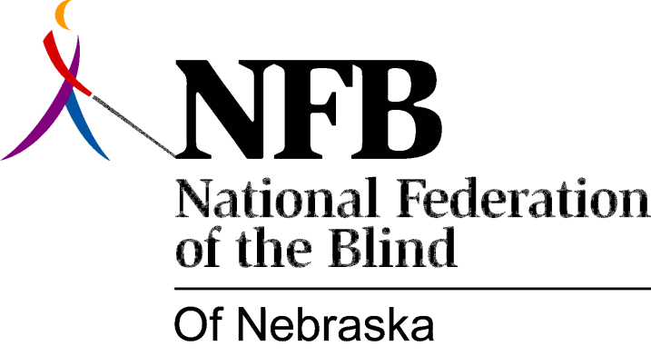

Resolution 1978 – 06
Re: Concerning Proposed Directory Assistance Charges

WHEREAS, North-Western Bell is formulating plans to charge for the use of Directory Assistance and

WHEREAS, telephone directories are not available to blind persons in a readily accessible form, and

WHEREAS, the National Federation of the Blind of Nebraska condemns and deplores the process of charging for Directory Assistance now, therefore,

BE IT RESOLVED, by the National Federation of the Blind of Nebraska in convention assembled this k8th day of June, 1978, in the city of Omaha, Nebraska, that this organization express its opposition to charging for Directory Assistance, to the Nebraska Public Service Commission and

BE IT FURTHER RESOLVED, that should such Directory Assistance charges be instituted, that this organization urge North-Western Bell to work with the National Federation of the Blind of Nebraska to implement the best possible exemption procedures for blind persons and

BE IT FURTHER RESOLVED, that the Secretary of this organization be instructed to send copies of this resolution to the Nebraska Public Service Commission, the President of North-Western Bell and other such persons as the Executive Board may deem necessary.

Passed, June, 1978.

