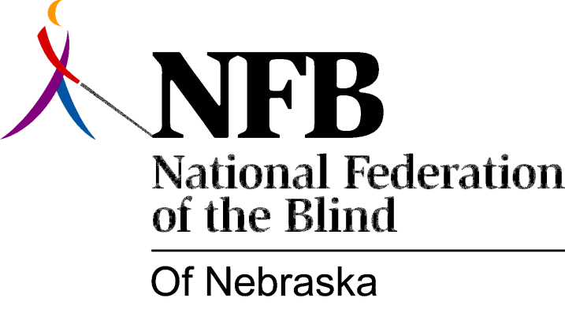

Resolution 1979 – 06
RE: Provision of Services to Blind Children by the Rehabilitation Agency

WHEREAS, Public Law 95-602, Rehabilitation Act Amendment of 1978, contains provisions that expand the traditional concept of rehabilitation to include "comprehensive services for independent living" and,

WHEREAS, the same law creates a program of reading services for the blind and,

WHEREAS, both these parts of the law explicitly identify services for handicapped children, and,

WHEREAS, Nebraska Services for the Visually Impaired has traditionally served only the adult blind, leaving an unmet need for services for younger blind persons and their families and,

WHEREAS, Nebraska Services for the Visually Impaired has the organizational capacity to provide these services on a state wide basis, now, therefore,

BE IT RESOLVED, that the National Federation of the Blind of Nebraska assembled this 20th day of flay, 1979, in the city of Hastings, Nebraska, that this organization strongly urges Nebraska Services for the Visually Impaired to develop plans to implement the legislative provision of Public Law 95-602, with particular emphasis on providing services to blind children, their families, their schools and, their communities and,

BE IT FURTHER RESOLVED, that this organization communicate with all members of the Nebraska Congressional Delegation to urge them to do everything in their power to insure adequate appropriations to carry out these essential programs.

Passed Unanimously

