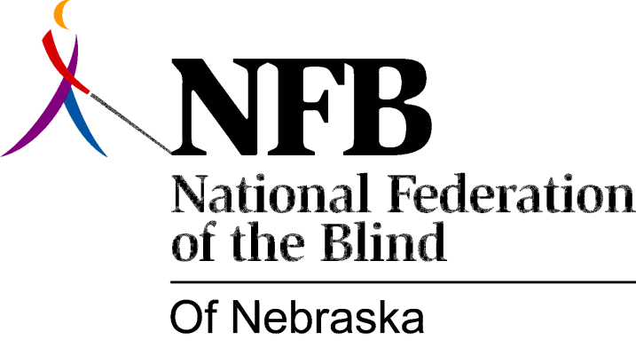

Resolution 1980 – 01
RE: Acceptance or Dismissal of the Task Force Recommendations by the Governor.

WHEREAS, the National Federation of the Blind of Nebraska is vitally interested in the delivery of high-quality rehabilitation services to blind Nebraskans; and,

WHEREAS, nationally, it has been found and authenticated by recent research that "the strongest, most effective and, most dynamic vocational rehabilitation systems are those in separate agency status": and,

WHEREAS, it is essential to the development of strong rehabilitation programs that the governor and the legislature be sensitive to the real needs of the blind and receptive to consumer input; and,

WHEREAS, the Governor's Task Force on Government Improvement recently recommended two changes in the operation of the Nebraska Services for the Visually Impaired:

1. "To consolidate vocational rehabilitation services for the visually impaired with vocational rehabilitation services for all other clients" and,

2. "To eliminate advocacy agencies from state government" specifically the advisory committee to Nebraska Services for the Visually Impaired: and,

WHEREAS, Governor Charles Thone has recognized the importance of separate agencies for the blind in his support of such legislation in the United States Congress; and,

WHEREAS, the National Federation of the Blind of Nebraska believes that such incorporation of services would result in severe and detrimental impact to the general well-being of the blind of Nebraska by further depriving the blind of the class of legitimate and effective rehabilitation service; now, therefore,

BE IT RESOLVED, by the National Federation of the Blind of Nebraska, in convention assembled this sixth day of December, 1980, in the city of Lincoln, Nebraska, that this organization does hereby urge Governor Charles Thone to recognize the importance of effective rehabilitation services for the blind of Nebraska, and the critical advantages of a separate agency for the blind, and therefore reject recommendations numbered 50, 51 and 84 of the Governor's Task Force on Government Improvement; and,

BE IT FURTHER RESOLVED, that the president of this organization instruct the secretary to send copies of this resolution to Governor Charles Thone, all members of the unicameral, and to other persons who are concerned with the general well-being of the blind of Nebraska; and,

BE IT FURTHER RESOLVED, that the governor's decision concerning recommendations 50, 51 and 84 of the Governor's Task Force on Government Improvement precipitate the issuance of the appropriate response by the Board of Directors of the National Federation of the Blind of Nebraska--1980-01A or 1980-01B.

Resolution 1980-O1A

BE IT RESOLVED, by the Board of Directors of the National Federation of the Blind of Nebraska on ____ date, as recommended by convention assembled this sixth day of December, 1980, in the city. of Lincoln, Nebraska, that this organization condemns and deplores the concept bf incorporating vocational rehabilitation services for the visually impaired with the vocational rehabilitation services for all other clients, and this organization abhors the elimination of the Governor's Advisory Committee to the Nebraska Services for the Visually Impaired, which effectively occludes a viable avenue of consumer in-put into agency operations; and,

BE IT FURTHER RESOLVED, that this organization take all necessary action to seek the defeat of any and all legislation which in any way would result in less effective services to the blind of Nebraska, such action to include, if deemed necessary by the president, public rallies and demonstrations; and,

BE IT FURTHER RESOLVED, that the president of this organization instruct the secretary to send copies of this resolution to all pertinent public officials, and other persons who are convened with the general well-being of the blind of Nebraska.

Resolution 1980-O1B

WHEREAS, Governor Charles Thone has recognized the negative impact these recommendations would have had and consequently rejected these recommendations, now, therefore,

BE IT RESOLVED, by the Board of Directors of the National Federation of the Blind of Nebraska, as recommended by the convention assembled on the sixth day of December, 1980, in the city of Lincoln, Nebraska, that this organization commends and applauds Governor Charles Thone for his decisive action against the recommendations, thereby helping to preserve better rehabilitation services for blind Nebraskans; and,

BE IT FURTHER RESOLVED, that the secretary of this organization be instructed to send a copy of this resolution to Governor Charles Thone.

