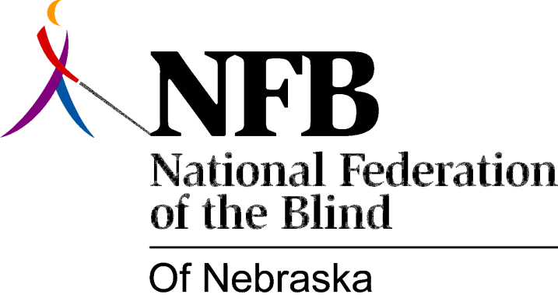

Resolution 1980 – 03
RE: Acceptance of Membership Subcommittee Guidelines.

WHEREAS, the National Federation of the Blind as an organized blind movement is the most effective means of dealing with the problems and issues concerning the blind; and,

WHEREAS, there remains a substantial number of blind Nebraskans who need to understand the impact of the blind movement on their lives and their right to participate; and,

WHEREAS, Resolution 1977-03 created a standing membership committee and set forth the intended goals of said committee; now, therefore,

BE IT RESOLVED, by the National Federation of the Blind of Nebraska, in convention assembled this seventh day of December, 1980, in the city of Lincoln, Nebraska, that this organization reaffirm its commitment by expending the necessary time, effort and funds to recruit and educate new and old members; and,

BE IT FURTHER RESOLVED, that the state membership committee gives thoughtful consideration to implementing the guidelines recommended by this special membership subcommittee, formed in August, 1980.

