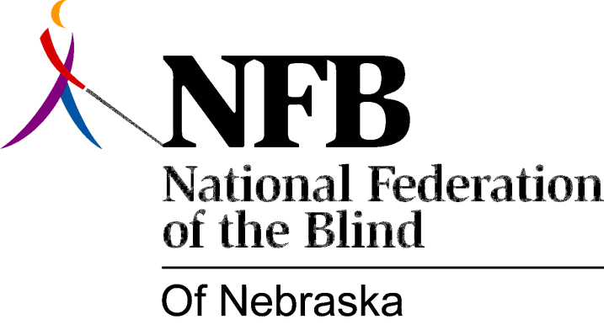

Resolution 1980 – 05
RE: The Rejection of the Five-Year Master Plan for the Education of Blind Children.

WHEREAS, the National Federation of the Blind of Nebraska has long held that the education of blind children should be conducted in a manner which promotes positive, healthy attitudes about blindness; and,

WHEREAS, the collective experience of the organized blind movement can be invaluable in coming to understand and deal effectively with the real problems of blindness; and,

WHEREAS, the Nebraska Department of Education has sponsored a committee to assist in the development of a five-year plan for the education of the visually handicapped, and did not give serious consideration to input from blind consumers and parents of blind children; and,

WHEREAS, this committee served essentially as a rubber stamp for the desires of the members of the Department of Education (Douglas Clark, Coordinator of Special Facilities for the Handicapped and Donna McKinley, State Consultant for Visually Handicapped Children) who coordinated and chaired committee operations; and,

WHEREAS, the consequences of this demeaning attitude resulted in a five-year plan which does not seek to promote the genuine and legitimate interests of high-quality education for blind children, but rather inherently serves the professional interests of those who will administer the plan; now, therefore,

BE IT RESOLVED, by the National Federation of the Blind of Nebraska, in convention assembled this sixth day of December, in the city of Lincoln, Nebraska, that this organization finds the five-year master plan for the visually handicapped to be unacceptable in its present form; and,

BE IT FURTHER RESOLVED, that this organization expend whatever resources it can to seek the ultimate initiation of an educational program for blind children which will be responsive to the real needs of the children; and,

BE IT FURTHER RESOLVED, that the president of this organization instruct the secretary to send copies of this resolution to Ann Campbell, Commissioner of Education, all members of the state Board of Education, Douglas Clark, Conna McKinley, Governor Charles Thone, and any other persons vitally interested in the education of blind children.

