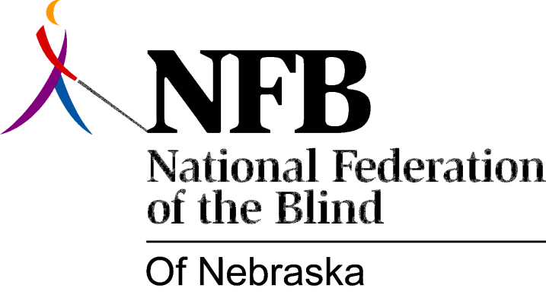

Resolution 1980 – 101
RE: NEOC Board Appointment

WHEREAS, the Nebraska Equal opportunity Commission (NEOC) is designed to help Nebraskans in resolving problems relating to discrimination, including employment discrimination; and,

WHEREAS, many of the complaints filed with the NEOC center around discrimination against ethnic minorities; and,

WHEREAS, in an attempt to be responsive to the needs of individuals facing racial discrimination, the NEOC is comprised of individuals who are representative of a variety of ethnic backgrounds, in this way being better able to serve effectively as advocates; and,

WHEREAS, even though since 1973 blind and disabled Nebraskans have been included in the Fair Employment Practice Act, they have never been represented on the Commission Board; and,

WHEREAS, in recent years, the blind have turned to the NEOC for help in resolving problems relating to discrimination against blindness which is daily encountered by blind people all across the country and is directly related to the overwhelming unemployment rate of blind people, which exceeds by many times the unemployment rate of any ethnic minority; and,

WHEREAS, the absence of a blind commissioner, who is representative of the organized blind, has resulted in the NEOC’s eing completely unprepared to deal effectively with discrimination cases relating to blindness, resulting in frustration and financial hardship for blind persons filing complaints; and,

WHEREAS, Governor Charles Thone will soon be making new appointments to the NEOC, now therefore

BE IT RESOLVED, by the Board of Directors of the National Federation of the Blind of Nebraska on this ninth day of August, 1980, that this organization urges Governor Charles Thone to appoint Marsha Bangert, President, national Federation of the Blind of Nebraska, to the NEOC so as to ensure that blind Nebraskans facing discrimination will be able to turn, with confidence, to the NEOC knowing that their cases will be dealt with reasonably and effectively.

Passed unanimously by the NFB-N Board of Directors and subsequently endorsed by affiliated chapters statewide, August, 1980.

