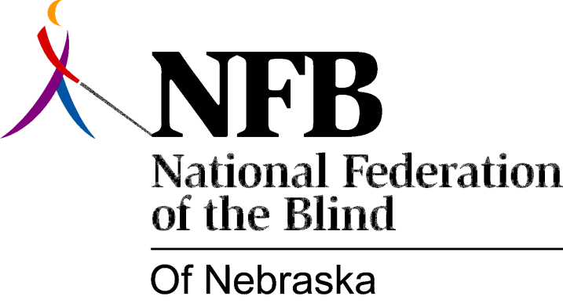

Resolution 1981 – 02
RE: Office of Affirmative Action

WHEREAS, the Department of Personnel, State of Nebraska, Office of Affirmative Action has an advisory committee mandated to oversee the functions of that office; and,

WHEREAS, the advisory committee to the Office of Affirmative Action, by law, is required to be made up of persons representative of protected classes, traditionally subject to discrimination in employment (race minorities, females, the handicapped, etc.); and,

WHEREAS, according to the Governor’s office and by admission of the Director of the Office of Affirmative Action members of the Advisory Committee to that office were personal choices of the Director, (Carol Walker) and not persons elected or nominated by groups or organizations representative of the protected classes; and,

WHEREAS, the lack of general contact and consultation with organizations of the blind for the representative structure is characteristic of the office of Affirmative Action; and,

WHEREAS, the National Federation of the Blind of Nebraska is our states largest organization of blind; now, therefore,

BE IT RESOLVED, by the National Federation of the Blind of Nebraska, in convention assembled in the city of Omaha, Nebraska, this 31st day of October, 1981, that this organization go on record as being opposed to the irresponsible and unrepresentative selection of advisory committee members to the Office of Affirmative Action; and,

BE IT FURTHER RESOLVED, that the president of this organization and the Employment committee of the national Federation of the Blind of Nebraska work with the Director of the Office of Affirmative Action and the Governor’s Office to bring about “true representation” within the advisory committee; and,

BE IT FURTHER RESOLVED, that the secretary of this organization be instructed to send copies of this resolution to, Carol Walker, Director Office of Affirmative Action, State Department of Personnel, Mr. Ron Sorenson, Director of State Merit System; Jan Piper, Director of State Personnel, and Governor Charles Thone.

