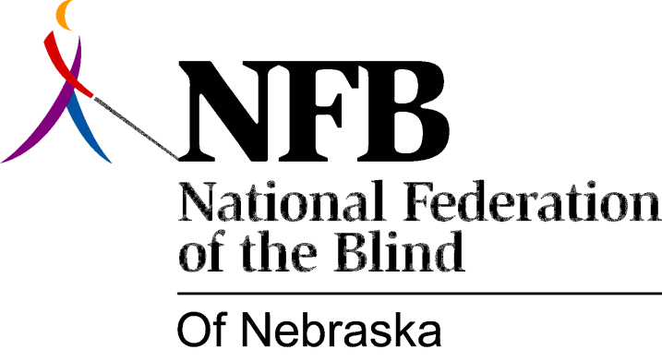

Resolution 1981 – 03
RE: Doty verses Holiday Skate World North

WHEREAS, on January 18, 1980 Gary Doty was denied access to the skating floor with the use of his long white cane at Holiday Skate World North; and,

WHEREAS, after Gary refused to give up the use of his long white cane, the Lincoln Police Department was called by the management to eject him; and,

WHEREAS, as a result of subsequent investigation by the Lincoln Commission on Human Rights which resulted in a finding of “just cause”, a public hearing was called (Doty verses Holiday Skate World North); and,

WHEREAS, during the course of the hearing Holiday Skate World north gave testimony stating that, it would be too dangerous for the long white cane to be used on the rink floor, while acknowledging other exceptions to their policy, i.e., hats: Thereby showing discrimination against all blind persons; now, therefore,

BE IT RESOLVED, by the national Federation of the Blind of Nebraska assembled in convention this first day of November 11981 in the city of Omaha, that this organization condemn and deplore the actions of the management of the Holiday Skate World North for it’s discrimination against the blind; and,

BE IT FURTHER RESOLVED, that this organization commend and applaud the Lincoln Commission on Human Rights for understanding the meaning of discrimination against the blind, and as evidence by its ruling of probable cause to believe that there was discrimination; and,

BE IT FURTHER RESOLVED, that this organization continue to educate the public, the business community, law makers and law enforcement authorities about the rights of blind people and the fact that these rights will be enforced.

