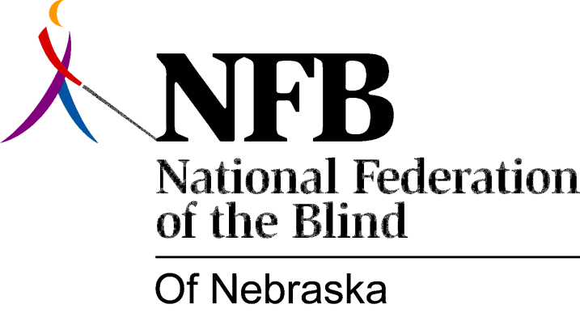

Resolution 1982 – 02
RE: Work to make changes to the Fair Employment Practices Act

WHEREAS, the Fair Employment Practices Act (FEPA) was written to eliminate discrimination against certain “Protected Classes”; and,

WHEREAS, changes in the FEPA are necessary before equal opportunity can be achieved; and,

WHEREAS, such changes should include; restructuring of the Equal Opportunity Commission, deletion of the word “intent” in connection with discrimination, and limiting the role of medical personnel to the certification of disability; now, therefore,

BE IT RESOLVED, by the National Federation of the Blind of Nebraska, in Convention assembled, this 17th day of October, 1982, in the city of Grand Island, Nebraska, that this organization work with the Unicameral to bring about appropriate changes in the Fair Employment Practices Act in order to promote equal opportunity.

