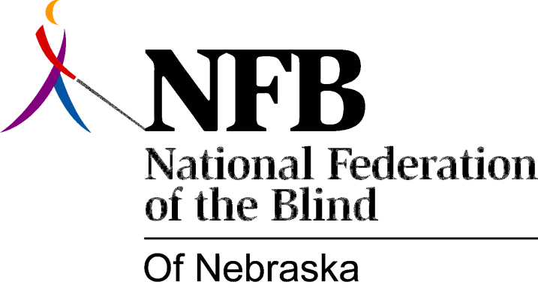

Resolution 1982 – 05
RE: Nebraska Library for the Blind and Physically Handicapped

WHEREAS, the current status of, and potential changes in library services for the blind, should and must be discussed with blind consumers; and,

WHEREAS, the National Federation of the Blind of Nebraska (NFB-N) is the largest organized group of blind consumers in Nebraska; and,

WHEREAS, the Director of the Nebraska Library for the Blind and Physically Handicapped (NLBPH) declined either to attend or send a representative to the State Convention of the NFB-N, saying that she and “all key staff” would be attending a meeting of the Advisory Committee to the NLBPH, a subcommittee of the Nebraska State Advisory Council on Libraries (NSACL); and,

WHEREAS, this subcommittee is directly responsible to the NSACL and not to the NLBPH; and,

WHEREAS, membership on the subcommittee is purely a matter of selection of individuals with no account taken of organizational representation; and,

WHEREAS, scheduling conflicts notwithstanding, sending all key staff to a meeting of a committee of the type described, while so sending no one to the Convention of the largest organization of the Blind in the state, makes neither practical nor administrative sense; and,

WHEREAS, our letter of invitation was intended to be a springboard from which further arrangements could be made, and not a mandate requiring adherence to the inflexible informalities; now, therefore,

BE IT RESOLVED, by the National Federation of the Blind of Nebraska, in Convention assembled this 17th day of October, 1982, in the city of Grand Island, Nebraska, that this organization reaffirm its’ position, stating that since issues of concern to library consumers are ongoing, it is appropriate that the NLBPH be represented at all Conventions of the NFB-N whenever and wherever they occur; and,

BE IT FURTHER RESOLVED, that the National Federation of the Blind of Nebraska continue the policy of nonparticipation in the Advisory Committee to the NLBPH, Subcommittee of the NSACL, working instead toward direct and meaningful input into Library Policies; and,

BE IT FURTHER RESOLVED, that relevant materials concerning the NFB-N, the NLBPH and the Advisory Committee be sent to the Director of the NLBPH; and ,

BE IT FURTHER RESOLVED, that this organization continue to invite the NLBPH to attend our Conventions, both for the presentation of information, and for informal interaction.

