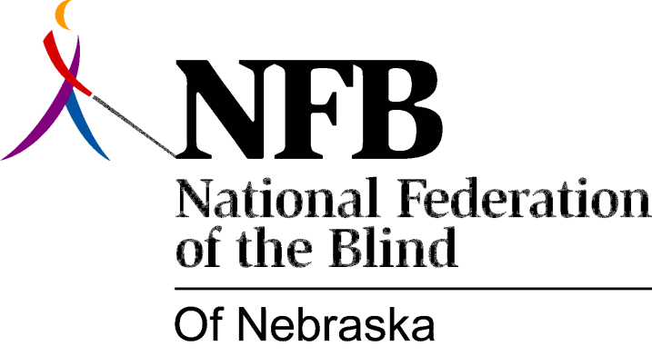

Resolution 1983 – 01
RE: Maintaining a Separate Agency for the Blind in Nebraska

WHEREAS, Governor Kerrey has entered into contracts with a number of national, prominent auditing firms to conduct management studies of state agencies including the Department of Public Institutions (DPI), which includes the Nebraska Services for the Visually Impaired (SVI); and,

WHEREAS, the Governor has been quoted in the Lincoln Journal as comparing this project with the Thone Task Force on Government Improvement; and,

WHEREAS, “governmental efficiency” was used by the earlier Task Force to justify a proposal to “consolidate” SVI with the General agency and to abolish the Advisory Committee to SVI; and,

WHEREAS, competent research and the experience of the blind have shown that a distinct and separate agency structure provides the best form of quality service to the blind; now, therefore,

BE IT RESOLVED, by the National Federation of the Blind of Nebraska in convention assembled this 16th day of October, 1983, in the city of Lincoln, Nebraska, that this organization urges the Governor and the Director of DPI to guard against the errors of the Thone Task force and to recognize the necessity of a distinct and separate agency for the blind in Nebraska; and,

BE IT FURTHER RESOLVED, that the NFBN calls upon the Governor and the Director of DPI to consult with the NFBN on these matters affecting the interests of the blind; and,

BE IT FURTHER RESOLVED, that the President of this organization take the necessary steps to protect the quality of services to the blind and secure the continuation of a separate and distinct service agency for the blind.

