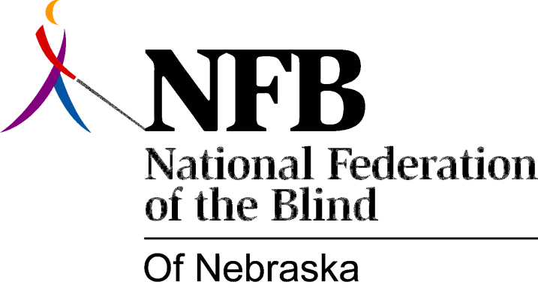

Resolution 1983 – 03
RE: Representation on SVI Advisory Committee

WHEREAS, the blind of Nebraska are taxpaying citizens and are consumers of services in Nebraska; and,

WHEREAS, specific governmental actions directly affect the quality of life of blind citizens; and,

WHEREAS, the organized blind have a strong concern for the quality of life of all blind people; and,

WHEREAS, the National Federation of the Blind is our state’s largest and most “representative” organization of the blind; and,

WHEREAS, the elected or appointed spokespersons for this organization are the true representatives of the blind in Nebraska; and,

WHEREAS, the law states that the Governor shall “seek fair representation of organizations of the blind and visually impaired”; and,

WHEREAS, this organization has submitted in writing an individual to represent us on the advisory Committee to Services for the Visually Impaired, and the Governor has refused to appoint this individual; and,

WHEREAS, repeated attempts to resolve the issues regarding this appointment have met with protracted inactions and refusal to cooperate in a reasonable fashion and has rendered the Advisory Committee ineffective; now, therefore,

BE IT RESOLVED, by the National Federation of the Blind of Nebraska in convention assembled this 16th day of October, 1983, in the city of Lincoln, Nebraska, that we urge Governor Kerry to abide by the “fair representation” requirement of the law; and,

BE IT FURTHER RESOLVED, that, in compliance with this requirement, we strongly urge the Governor to appoint the designated representative of the NFBN to fill the vacancy of the former representative of this organization to the Advisory Committee.

