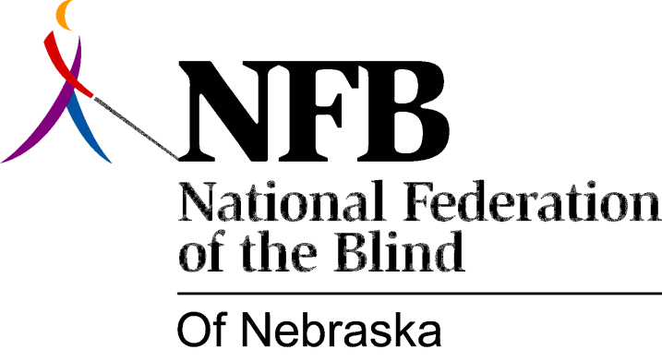

Resolution 1983 – 04
RE: Special Park in Omaha for the Blind and Handicapped

WHEREAS, the Nebraska Association of Landscape Architects, with assistance from the Rotary Club of Omaha, has designed and plans to construct a new, special park for the blind and handicapped; and,

WHEREAS, the park is being promoted as a special place for the blind and handicapped by having such items as a “touch and smell garden”; and,

WHEREAS, the Peter Kiewit Foundation has pledged $125,000 for the construction of this park with the remaining funds contributed by the Rotary Club and contributions from the community; and,

WHEREAS, we recognize the importance of equal access to all public facilities for all citizens of our state; and,

WHEREAS, the establishment of such special facilities has always perpetuated segregation rather that equality for the blind; and,

WHEREAS, the assumed needs of the blind for such modifications are not necessary and are generally pursued without first consulting with the blind; now, therefore,

BE IT RESOLVED, by the National Federation of the Blind of Nebraska in convention assembled this 16th day of October, 1983, in the city of Lincoln, Nebraska, that this organization communicate with the groups involved in this project so that they may realize the true needs of blind people; and,

BE IT FURTHER RESOLVED, that meaningful, on-going dialogue be established in order to prevent any reoccurrence of similar projects or activities which address the perceived needs or concerns of the blind without first consulting with this organization.

