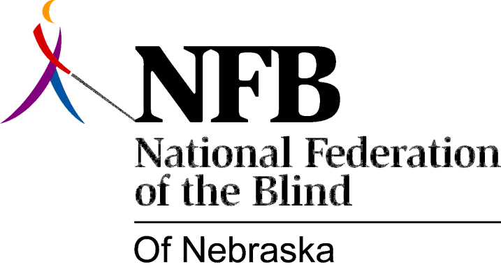

RESOLUTION 1984-01

RE: Summer Independent Living Program for Blind Youth

WHEREAS, Nebraska Services for the Visually Impaired has sponsored a program to enhance the independence of blind youth in Nebraska; and,

WHEREAS, the fostering of independence is an integral part of the National Federation of the Blind; and,

WHEREAS, currently, state rehabilitation agencies receive no federal support for services to blind youth; and,

WHEREAS, the N.F.B. is not subject to federal regulatory constraints, thus allowing for greater flexibility for development and service delivery; and,

WHEREAS, the highest quality of services is provided when agencies serving the blind work in conjunction with the organized blind movement; now, therefore,

BE IT RESOLVED, by the National Federation of the Blind of Nebraska, in convention assembled this 13th day of October, 1984, in the city of North Platte, Nebraska, that this organization take a leadership role in a cooperative effort with Nebraska Services for the Visually Impaired to provide a summer independent living program for blind youth in Nebraska; and,

BE IT FURTHER RESOLVED, that the F.F.B.N. initiate with N.S.V.I. the planning and implementation of this program.

