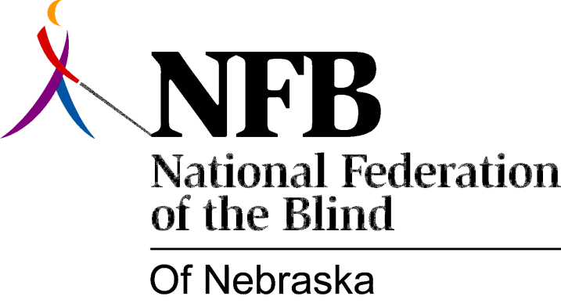

RESOLUTION 1984-05

RE: Nebraska School for the Visually Handicapped Advisory Committee

WHEREAS, the members of the National Federation of the Blind of Nebraska feel that consumer input is essential to the provision of a quality education to blind children; and,

WHEREAS, advisory committees can facilitate open communication between consumers and program administrators; and,

WHEREAS, there is currently in existence an advisory committee to the Nebraska School for the Visually Handicapped, composed of: two parents of N.S.V.H. students; two teachers at the school; two representatives from the State Board of Education and the Assistant Commissioner of Education; now, therefore,

BE IT RESOLVED, by the National Federation of the Blind of Nebraska, in convention assembled this 13th day of October, 1984, in the city of North Platte, Nebraska, that this organization call upon the existing advisory committee to include in its membership two consumer representatives, one being a member of the National Federation of the Blind of Nebraska, and a representative of the student body at N.S.V.H.; and,

BE IT FURTHER RESOLVED, that the secretary of this organization be instructed to send copies of this resolution to: the Commissioner of Education; the members of the State Board of Education; the head administrator of the Nebraska School for the Visually Handicapped and the members of the advisory committee to N.S.V.H.

