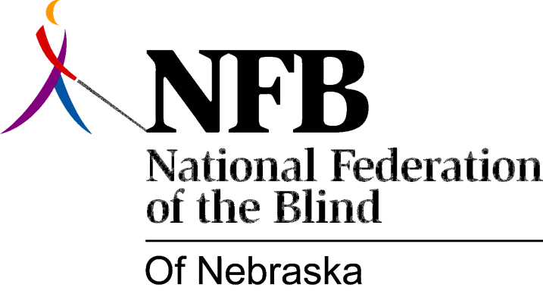

RESOLUTION 1985-04

RE: Consolidation of the Nebraska Schools for the Deaf and Blind

WHEREAS, it is both desirable and necessary to provide the highest quality education for blind children in Nebraska; and,

WHEREAS, the special educational needs of blind children are different from those of other children needing special educational programs; and,

WHEREAS, the Nebraska Unicameral has passed L.R. 192 providing for a study of the feasibility or desirability of consolidating the schools for the blind and the deaf; and,

WHEREAS, in order to provide the highest quality education program for blind children, it is imperative that separate and identifiable residential programs be maintained: Now, therefore,

BE IT RESOLVED, by the National Federation of the Blind of Nebraska, in Convention assembled this 12th day of October, 1985, in the city of Grand Island, Nebraska, that this organization reaffirm its long-standing opposition to consolidation of programs for the sensory impaired; and,

BE IT FURTHER RESOLVED, that this organization call upon the Unicameral to maintain a separately administered and identifiable program on a separate campus which provides quality education to blind children; and,

BE IT FURTHER RESOLVED, that this organization take any steps necessary to oppose and present any such consolidation.

