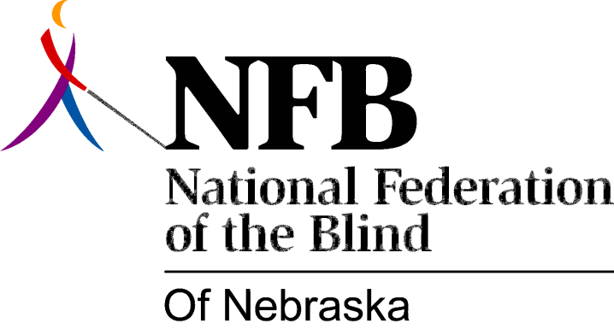

Resolution 1985-101

RE: Voting Accessibility for the Elderly and Handicapped Act

WHEREAS, the “Voting Accessibility for the Elderly and Handicapped Act” was enacted on June 1st, 1985; and,

WHERAS, persons (blind or sighted) should have the opportunity to vote in their home precincts, thus eliminating the need for separate or segregated polling places; and,

WHEREAS, accessibility for the blind in polling places does not necessitate sophisticated electronic devices or other gadgetry, but can be accomplished through the use of alternatives such as: poll workers acting as readers, personal readers or absentee ballots; and,

WHEREAS, often, equal access for blind people can be more easily and effectively achieved through public education than through expensive modifications; and,

WHEREAS, the National Federation of the Blind of Nebraska, as the oldest and largest group of blind consumers in the State, is most willing and eminently qualified to act as a resource in carrying out this and other such legislative mandates regarding the blind: Now, therefore,

BE IT RESOVED by the Board of Directors of the National Federation of the Blind of Nebraska, in the meeting assembled this ninth day of November, 1985, in the City of Norfolk, Nebraska, that this organization call upon the Secretary of State to work with the NFBN in order to implement the “Voting Accessibility for the Elderly and Handicapped Act” as it relates to blind people, in an inexpensive, effective manner; and

BE IT FURTHER RESOLVED that this organization and the Secretary of State work together to educate the public (especially poll workers and blind consumers) as to the alternatives which are available to blind voters.

Passed By the Board

