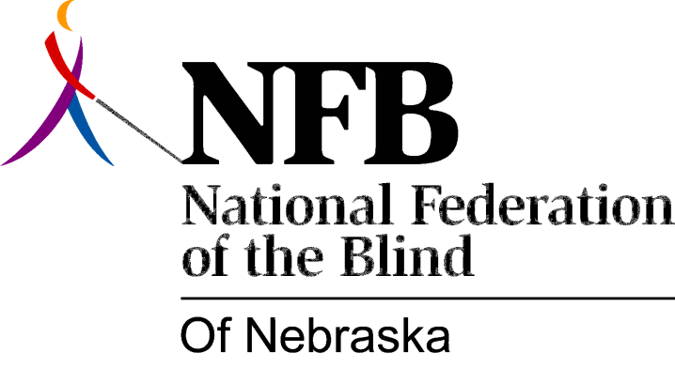

Resolution 1986-01

RE: Little Randolph-Sheppard Act

(Summary)

This resolution calls upon the Nebraska Unicameral to pass legislation giving priority to blind vendors in public vending facilities, or to pass a Little Randolph-Sheppard Act in Nebraska. This resolution also calls upon us to work closely with the sponsoring senator and any other agency or organization concerned with blind vendors in the drafting of this legislation.

Passed

