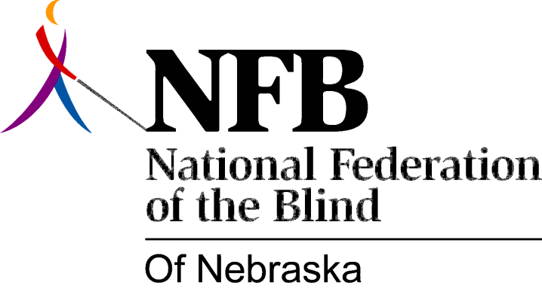

Resolution 1988-02

RE: Radio Talking Book, Inc.

WHEREAS, the National Federation of the Blind of Nebraska has supported the concept of a radio reading service since the inception of Radio Talking Book, Inc. (RTB) in 1974; and,

WEREAS, we view RTB as a vital link in the service system for the blind in Nebraska, and not simply as a special-population project of the public television and radio service; and,

WHEREAS, the management and Board of RTB are proposing to remove the radio reading service from its present budgetary administrative location within the State of Nebraska Department of Public Institutions Division of Rehabilitation Services for the Visually Impaired (SVI), and transfer its budget request to the Nebraska Education Telecommunications Commission; and,

WHEREAS, this transfer would significantly lower the budget priority status of RTB in comparison with its demonstrated priority within the SVI budget process; and,

WHEREAS, while we are pleased that the transmission facilities of Nebraska Educational Television are being used under a Federal grant to expand the service statewide, we believe that the method of carrying the signal is much less important as a factor in the placement of the budget than the fact that RTB is a program for blind persons; now, therefore,

BE IT RESOLVED, by the National Federation of the Blind of Nebraska in Convention assembled this 9th day of October, 1988, in the city of Grand Island, Nebraska, that this organization urges the board and management of RTB to review their decision to pursue this change in the light of the facts and of the history of the past support of SVI; and,

BE IT FURTHER RESOLVED, that, if this redetermination does not occur, this organization takes whatever steps may be necessary to oppose this change, in the Legislature’s appropriations Committee and elsewhere.

Adopted Unanimously.

