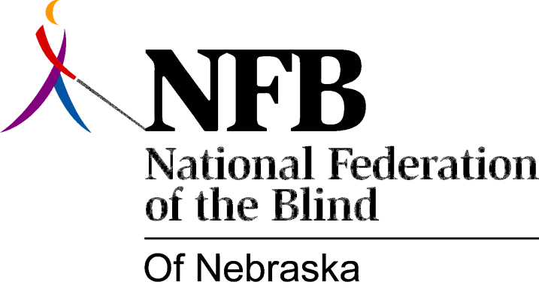

RESOLUTION 1991-03

RE: The Treatment of Blind Passengers of MAT

WHEREAS, most blind persons use public transit as their principle means of transportation from one point to another, when feasible and reliable; and

WHEREAS, the leadership of the Omaha Chapter of the National Federation of the Blind of Nebraska (NFBN) met with Robert Courtright, Executive Director of Metro Area Transit (MAT) and members of his staff to discuss problems of equal access for the blind and to develop guidelines to resolve issues of concern to the blind; and

WHEREAS, members of the Omaha Chapter offered technical assistance and training to all MAT drivers and staff, thus attempting to resolve problems encountered by the blind; and

WHEREAS, this training, at first, was extremely successful, but as time passed, MAT drivers fell into old patterns of negative behavior thus causing problems to resurface; and

WHEREAS, the blind are once again, treated with total disrespect and arrogance by some drivers; and

WHEREAS, the problems encountered by the blind are attitudinal in nature and are definitely issues of common sense and judgment; now, therefore,

BE IT RESOLVED THAT the National Federation of the Blind of Nebraska, in convention assembled this 6th day of October, 1991, call upon the Executive Director to ensure that all blind persons using MAT are treated with dignity and respect by MAT drivers and that drivers who fail to comply with directives relating to issues of equal access be disciplined accordingly; and

BE IT FURTHER RESOLVED THAT members of the Omaha Chapter be given additional opportunities to train MAT drivers; and

BE IT FURTHER RESOLVED THAT the NFBN will use all legal remedies available to ensure that all blind citizens are provided equal access to public transit.

