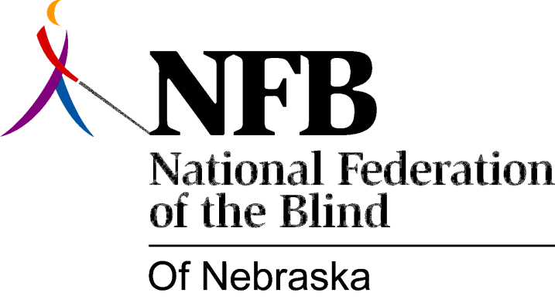

RESOLUTION 1993-02

RE: Opposition to Audible Traffic Signals

WHEREAS; blind persons throughout the State of Nebraska have completely demonstrated their ability to travel independently; and

WHEREAS; audible traffic signals have been installed at busy intersections to supposedly enable the blind to travel in a safer environment; and

WHEREAS; however, these devices have proven to be a menace, rather than an issue of safety, often placing blind persons in life threatening situations; and

WHEREAS; audible traffic signals have been forced upon blind citizens due to misconceptions on the part of well-intentioned governmental officials and citizens; and

WHEREAS; Resolution 92-06 passed at the National Convention of the National Federation of the Blind in Charlotte, North Carolina opposed installation of audible traffic signals; now, therefore,

BE IT RESOLVED by the National Federation of the Blind of Nebraska, in convention assembles this 16th day of October, 1993, in Columbus, Nebraska, that this organization continue to oppose the installation of audible traffic signals; and

BE IT FURTHER RESOLVED THAT this organization will assist any blind person who is injured at an intersection with such a device in operation; and

BE IT FURTHER RESOLVED THAT the NFB take the necessary steps to properly inform the general public and governmental officials about the perils of audible traffic signals; and

BE IT FURTHER RESOLVED THAT copies of this resolution be distributed to the mayor or city manager of every municipality in Nebraska.

