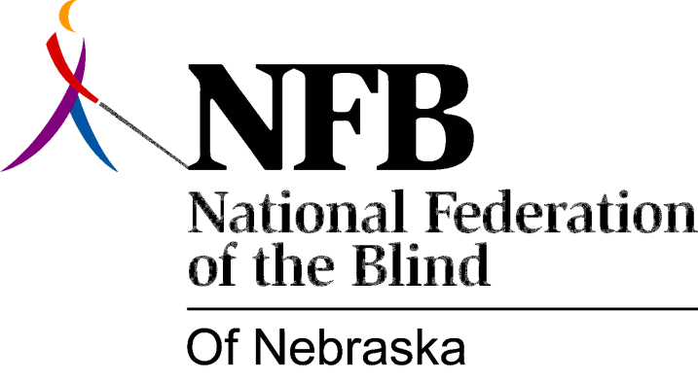

RESOLUTION 1993-03

RE: Support of VIPS Groups in Nebraska

WHEREAS; according to the 1990 Census there were 21,429 blind Nebraskans who were 55 years of age or better and 1,725 persons below age 55 who were blind; and

WHEREAS; Nebraska Services for the Visually Impaired reports that 872 people received independent living services in 1992; and

WHEREAS; in that same year 542 blind Nebraskans participated in one of a network of 30 support groups across the state known as "Visually Impaired Peer Support" (VIPS); and

WHEREAS; the purpose of the National Federation of the Blind is further consumer involvement in issues regarding blindness and to encourage its members in pursuing active, independent lives; and

WHEREAS: the VIPS are not a political organization and do not in any way oppose any of our goals; now, therefore,

BE IT RESOLVED by the National Federation of the Blind of Nebraska in convention assembles this 16th day of October in the city of Columbus, that this organization applaud and support this group of newly blind citizens in their efforts to encourage the blind in pursuing active, independent life styles; and

BE IT FURTHER RESOLVED that the NFBN will take the initiative in establishing dialogue with the VIPS board of directors and make ourselves available to meet with the VIPS group and tell the story of the NFB; and

BE IT FURTHER RESOLVED that we invite VIPS members to become members of the National Federation of the Blind of Nebraska, receive the Braille Monitor and/or support our organization through Associate membership.

