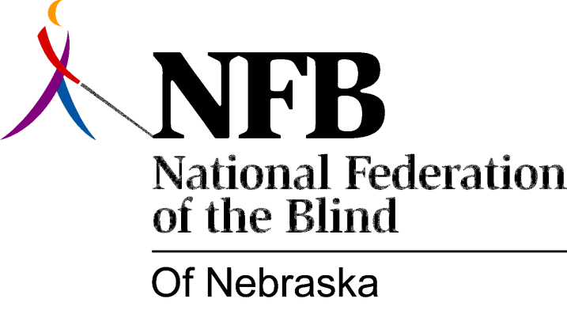

RESOLUTION 1993-04

RE: Creation of a Separate Commission for the Blind in the State of Nebraska

WHEREAS, the National Federation of the Blind, the largest organization of the blind in the United States, has a long history of supporting the concept of "separate" agencies or commissions for the blind; and

WHEREAS, it has been consistently demonstrated over a period of time that blind persons, as clients of these separate agencies or commissions, receive better services and thus, following training, compete, to a far greater degree, on an equal basis with their sighted peers; and

WHEREAS, these separate agencies are usually governed by a separate and distinct board of directors, who are appointed by and report to the governor of the state on matters involving services for blind citizens; and

WHEREAS, the State of Nebraska currently does not have such a separate agency or commission for the blind with a board of directors; now, therefore,

BE IT RESOLVED by the NFB of Nebraska assembles in convention this 16th day of October, 1993, that this organization take whatever legislative and/or administrative steps it deems necessary to bring about the creation of a separate commission for the blind in the State of Nebraska.

