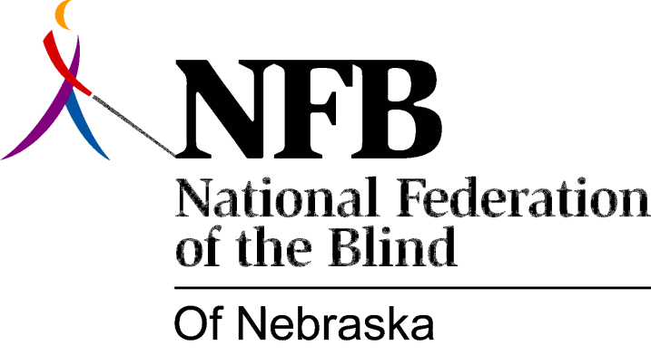

RESOLUTION 1993-07

RE: Negative Advertisements by the Tobin Eye Institute

WHEREAS; the Omaha Tobin Eye Institute portray blind persons in a negative manner in their television advertisements; and

WHEREAS; these advertisements imply that blind people cannot enjoy or participate in life without "no stitch cataract surgery"; now, therefore,

BE IT RESOLVED by the National Federation of the Blind of Nebraska, in convention assembled this 17th day of October, 1993, in the city of Columbus, that we call upon Omaha Tobin Eye Institute to cease and desist this negative advertising; and

BE IT FURTHER RESOLVED that we offer to work with Omaha and Tobin Eye Institutes to establish a more positive image of blindness in their advertising segments.

