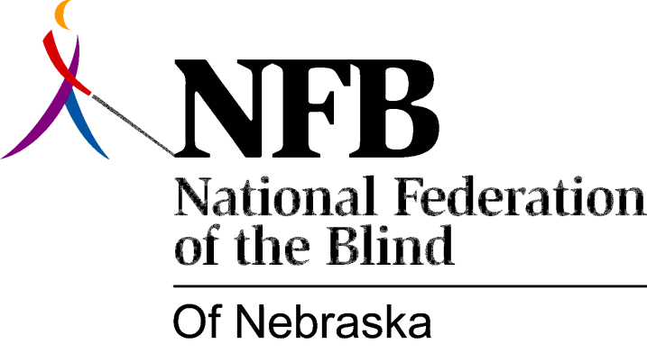

Resolution 1996-01

RE: Asking RTBS to support Newsline

Whereas, The National Federation of the Blind operates Newsline for The Blind, making it possible for blind persons to read: “USA Today”, “The New York Times”, and “The Chicago Tribune”, every day, simply by using a touch-tone phone; and

Whereas, Establishing local service centers in Nebraska, to carry the Newsline signal into our communities, would enable blind citizens living in our state to dial into Newsline without incurring a long-distance telephone bill, making the daily newspaper truly accessible to blind Nebraskans; and

Whereas, These local service centers could also carry area newspapers, such as: “The Omaha World Herald”, and “The Lincoln Journal Star”; and

Whereas, The National Federation of the Blind of Nebraska stands committed to actively raising funds and seeking contributing sponsors for a Newsline network in Nebraska; and

Whereas, Radio Talking Book Services is an organization dedicated to enabling blind persons throughout the state to access the daily newspaper and other print materials, in an auditory format; and

Whereas, A Newsline system in Nebraska would make local, daily newspapers available to blind RTB listeners, thereby assisting Radio Talking Book Services in accomplishing a part of its mission; now, therefore,

Be It Resolved, by the National Federation of the Blind of Nebraska, in Convention assembled this 13th day of October, 1996, in the City of Columbus, Nebraska, That we call upon Radio Talking Book Services to work, in cooperation with this organization, in establishing a local service center in Omaha, bringing Newsline to blind persons living in the Omaha Metropolitan area; and

Be It Further Resolved, That copies of this resolution be presented to the Executive Director of Radio Talking Book Services and to the members of the RTB Board of Directors.

