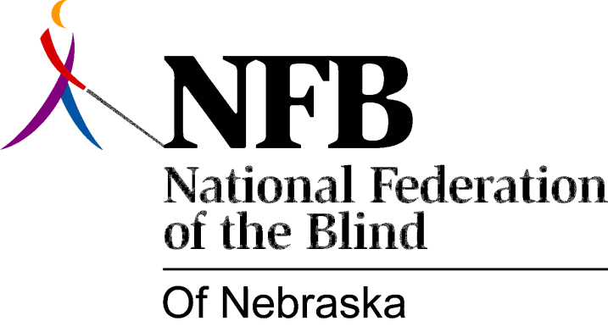

Resolution 1996-04

RE: Financial Assistance to Attend NFB Conventions

Whereas, The National Federation of the Blind has had a long-standing tradition of giving partial assistance to members and prospective members of this organization, wishing to attend both state and national conventions; and

Whereas, scholarship finalists have been the only persons given full financial assistance to attend state and national conventions; and

Whereas, our limited funds will not allow us to offer full assistance to all persons we would like to have at conventions; now, therefore,

Be It Resolved, by the National Federation of the Blind of Nebraska, in convention assembled this 13th day of October, 1996, in the City of Columbus Nebraska, that here and after full convention assistance be provided only to scholarship finalists while all other members and prospective members, including SVI Orientation Center students, shall be eligible to receive partial funding to assist them in attending state and national conventions.

