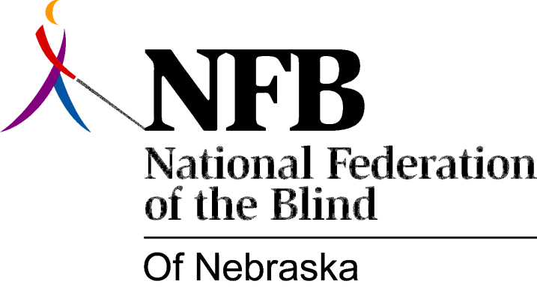

Resolution 2000-02
RE: Access to ATM Machines
WHEREAS, the National Federation of the Blind of Nebraska (NFBN) is the voice of the active organized, blind in this state; and
WHEREAS, it is the mission of the NFBN to promote equality, opportunity, and security for the blind; and
WHEREAS, equal access to publicly available information is a vital need for all citizens, including the blind; and
WHEREAS, the ability to privately handle personal finances is important to everyone, including the blind; and
WHEREAS, the Automatic Teller Machine (ATM) is becoming one of the most popular tools for personal finance management; and
WHEREAS, these machines are typically inaccessible to the blind; and
WHEREAS, technology exists for making them accessible; now, therefore,
BE IT RESOLVED by the National Federation of the Blind of Nebraska, in Convention assembled this eighth day of October, 2000, in the city of Omaha, Nebraska, that this organization urge the banking industry in this state to work with us to make ATM equipment accessible to the blind and other print reading impaired persons.

