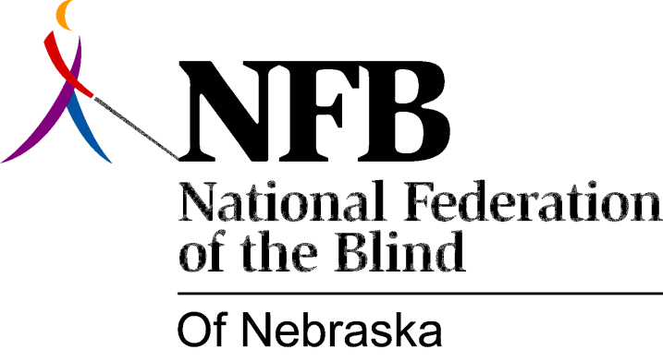

Resolution 2000-03
RE: Access to Print on Television
WHEREAS, the National Federation of the Blind of Nebraska (NFBN) is the voice of the active organized blind of this state; and
WHEREAS, it is the mission of the NFBN to promote equality, opportunity, and security for the blind; and
WHEREAS, equal access to publicly available information is vitally necessary for all citizens, including the blind; and
WHEREAS, the blind are routinely denied access to textual information flashed on the screen such as emergency weather updates, news bulletins scrolled along the bottom of the screen, sports scores, school closings, program guides, phone numbers in advertisements, the identities of speakers during news programs, and other data not otherwise read aloud; and
WHEREAS, technology exists which can render these accessible to the blind in auditory/real-time formats; now, therefore,
BE IT RESOLVED by the National Federation of the Blind of Nebraska in Convention assembled this eighth day of October, 2000, in the city of Omaha, Nebraska, that this organization call upon state-wide television media to make all such data available in accessible formats for blind and otherwise print reading impaired Nebraskans.

