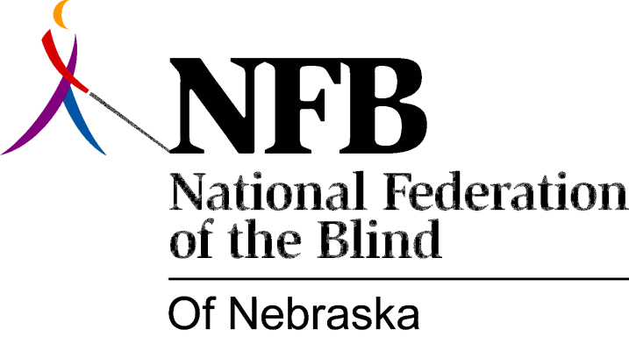

Resolution 2001-01

RE: Playing Presidential Releases

WHEREAS, the National Federation of the Blind is the largest organization of the blind in the United States; and

WHEREAS, the Federation has affiliates, chapters and divisions in all 50 states, the District of Columbia, and Puerto Rico; and

WHEREAS, each affiliate, chapter and division has the common purpose of promoting the welfare of the blind; and

WHEREAS, each Federation affiliate, chapter and division has as its mission the social, political and economic integration of the blind into society as equal partners; and

WHEREAS, the intent of the Federation, as expressed through its various constitutions-national, state and local-is to work, through the collective action of a unified and united movement, for the advancement of the blind; and

WHEREAS, in order to promote self-advocacy and enhance the empowerment of all blind persons, the National Federation of the Blind has created the Presidential Release; and

WHEREAS, the Presidential Release is designed to facilitate the communication of vital information and boost the morale of the entire organization; and

WHEREAS, the presidential Release has been adopted as a valuable agenda item in meetings of Federation affiliates across the United States since November, 1972; and

WHEREAS, this communication vehicle is the best and most regular source for conveying such necessary material and Federation spirit in a brief, concise and timely fashion; and

WHEREAS, this monthly supplement to other Federation communications, such as THE BRAILLE MONITOR, is presented in the recorded voice of our National President, Dr. Marc Maurer, which makes it a unique opportunity for all Federationists to connect in the most direct way possible with our national leadership: Now, therefore,

BE IT RESOLVED by the National Federation of the Blind of Nebraska in Convention assembled this seventh day of October, 2001, in the city of North Platte, Nebraska, that the tradition of playing the official monthly National Federation of the Blind Presidential Release at all local chapter meetings and other similar Federation gatherings throughout the state of Nebraska henceforth be adopted as formal standing policy of the National Federation of the Blind of Nebraska.

