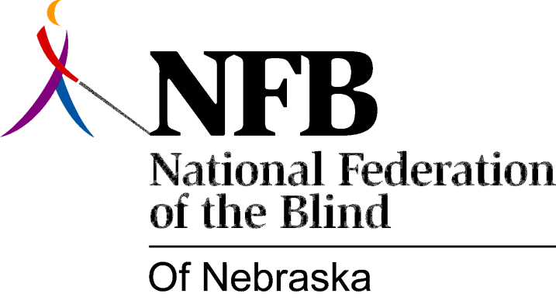

RESOLUTION 2004-02

RE: Computer Options

WHEREAS, Computer Options, a program offered by the National Federation of the Blind of Nebraska (NFBN) to blind people, primarily those over age 55, was in operation from February of 2001 through January of 2003; and

WHEREAS, since that time, while continuing to serve one student and field questions by telephone from others, reduced available space and lack of an internet connection resulted in the NFBN's being unable to do more; and

WHEREAS, this vital service was meeting the needs of a vastly underserved niche market in our community; and

WHEREAS, while the NFBN initiated the program with funds from a demonstration grant, and while the NFBN both sought and received further funding, the subsequent grants received were smaller and ultimately were not enough to cover ongoing expenses; and

WHEREAS, the NFBN has been trying to find a way not only to continue the program, but also to remain downtown, because transportation is an ongoing issue for blind people and all busses serve that area; and

WHEREAS, since one out of every six seniors is either blind or visually impaired, and since one of the main avenues of communication for them as well as other seniors is the use of computers, the NFBN has long believed that an ideal place to provide the service would be in the Senior Center at 10th and O; and

WHEREAS, earlier this year, in meetings with June Pederson, Director of the Lincoln Area Agency on Aging and members of her staff, the partnership the NFBN has hoped for began to take shape; and

WHEREAS, THE Senior Center has agreed to provide space, furniture, connection to the internet, and leads to potential funding; and

WHEREAS, the NFBN will provide computers, Braille and print printers, a scanner, speech output screen reader software, an instructor, and tech support; and

WHEREAS, students who come to the Senior Center to take part in the NFBN's program will also have access to other services offered there, making it a win-win situation for everyone; and

WHEREAS, Coleen Seng, Mayor of Lincoln, has actively participated in the creation of this partnership; Now, therefore,

BE IT RESOLVED by the National Federation of the Blind of Nebraska, in Convention assembled this ninth day of October, 2004, in the city of Lincoln, Nebraska, that this organization commends both The Honorable Coleen Seng, Mayor of Lincoln, and June Pederson, Director, Lincoln Area Agency on Aging, for partnering with the NFBN in the revitalization of Computer Options, recognizing that their city government and aging services expertise and the NFBN's expertise in blindness make possible a dynamic new opportunity for changing what it means to be blind in this community.

