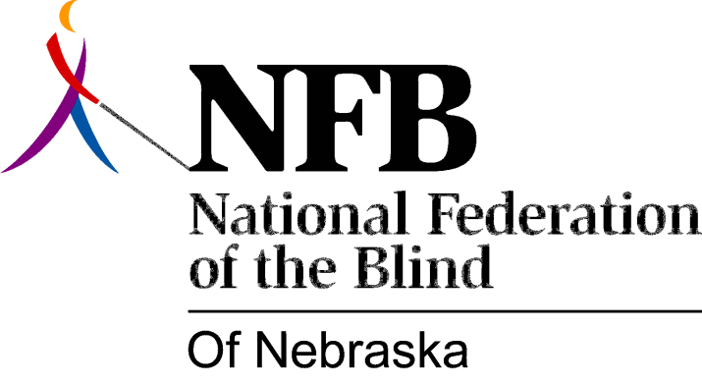

RESOLUTION 2008-02

RE: Literary Braille Competency

WHEREAS, Braille, the system of tactual dot combinations that represent all manner of necessary print symbols, since the time of its creation nearly 200 years ago, has become the preferred and only true means of independently reading and writing for the blind; and

WHEREAS, contemporary estimates of the unemployment and underemployment rates among the blind and visually impaired in the United States are at least 70 percent; and

WHEREAS, additional estimates show that, of the 30 percent or fewer blind persons who are employed in any capacity, 90 percent utilize Braille to accomplish at least some task in their working environment, regardless of their visual acuity; and

WHEREAS, despite the clear correlation between employment success for the blind and knowledge and use of the Braille code, since the onset of the mainstreaming movement in the 1960’s, the percentages of blind and visually impaired children either offered or taught Braille have dropped to dismal estimates hovering around 10 percent; and

WHEREAS, today’s university training programs designed to prepare persons for delivering Braille instruction as part of their “teaching the visually impaired” endorsement use texts and research which quote the Braille reading rates for the average adult to be at or below half the average reading rates published for print readers; and

WHEREAS, to the extent that this statistic is true, it is a result of the training which influences not only how and what are taught to these prospective educators, but also the prevailing attitudes and expectations for the use of Braille that they pass along to their students; and

WHEREAS, university students in Nebraska learn Braille almost exclusively online in an independent study manner with visually based “sim” Braille dots that only appear on a computer screen; and

WHEREAS, the “Braille” these students produce to reflect their newly acquired knowledge is also largely done on a computer keyboard with the resulting “Brailled” text only appearing visually, making it possible for people to receive an endorsement to teach Braille without ever interacting with the genuine tactual code itself; and

WHEREAS, the university course work for teaching Braille to the future “teachers of visually impaired students” is mainly grounded in the manual designed by the National Library Service for the purpose of certifying persons as transcribers and proofreaders, not Braille instructors; and

WHEREAS, the exam required to complete a “Vision Teacher” endorsement in Nebraska, which consists exclusively of sentences to be Brailled, only assesses a person’s knowledge of Braille code rules, thus reflecting this transcribers methodology; and

WHEREAS, the National Library Service (NLS) and the National Federation of the Blind (NFB) have recently constructed an exam, The National Literary Braille Competency Test (NBLCT), which is currently being administered by the National Blindness Professionals Certification Board (NBPCB); and

WHEREAS, a candidate who successfully passes the NLBCT receives an endorsement known as the National Certification in Literary Braille (NCLB); and

WHEREAS, the four major sections of this test: (1) Braille writing using a Braille writer, (2) Braille writing using a slate and stylus, (3) Proofreading, identifying Braille errors and (4) Multiple choice questions, correct usage and rules, comprise a great advancement in the assessment of a person’s knowledge of Braille and are more reflective of all the reading and writing skills needed for both Braille instructors and their students to be successful; and

WHEREAS, utilization of this test would make possible major strides toward insuring high quality instruction as well as national credibility for our Nebraska trained and locally practicing professionals: Now, therefore,

BE IT RESOLVED by the National Federation of the Blind of Nebraska in convention assembled this 12th day of October, 2008, in the city of Grand Island, Nebraska, that we call upon the Nebraska Department of Education, the Nebraska State Legislature, and all other policy making bodies governing the education of blind and visually impaired children in this state to require that all persons engaging in teaching Braille and/or responsible for producing Braille materials for such children pass the National Literary Braille Competency Test and earn their National Certification in Literary Braille as a prerequisite for receiving a “Vision Teacher” endorsement in the State of Nebraska.

