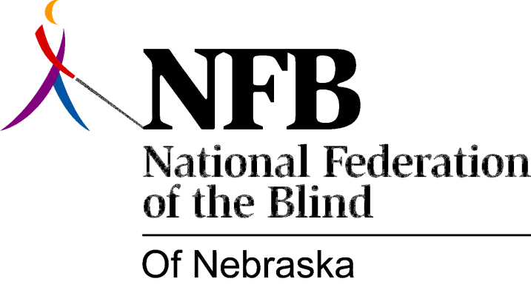

Resolution 2010 – 01
RE: Regarding The Vending Facility Bidding Process

WHEREAS, both state and federal governments have long recognized that the Randolph-Shepard Program for blind vendors is crucial in helping to mitigate the roughly 70% unemployment rate among blind people, AND,

WHEREAS, blind vendors have operated successfully in the Lincoln State Office Building, Capital Building and, other state facilities for many years, AND,

WHEREAS, the State of Nebraska especially in recent years has not given blind vendors priority in state facilities similar to those offered at the federal level and in many other states as well, AND,

WHEREAS, it is in the best interest of the State of Nebraska to foster local Nebraska businesses when they employ blind individuals recognizing high unemployment rates in this group, AND,

WHEREAS, the State of Nebraska has decided to replace the blind vendors currently managing facilities in both the Lincoln State Office Building and the State Capital Building with an out of state corporate entity Pepsi First Choice Vending, AND,

WHEREAS, this is a direct contradiction to Governor Heineman’s pledge to help blind persons achieve gainful employment, NOW THEREFORE,

BE IT RESOLVED, by the National Federation of the Blind of Nebraska in convention assembled this 31st day of October 2010 in the city of Columbus, Nebraska that this organization condemn and deplore this action by the State of Nebraska to take jobs away from blind vendors and give them to a giant out of state corporation Pepsi First Choice Vending, AND,

BE IT FURTHER RESOLVED, that we call upon the Governor to investigate the process through which this contract was bid and awarded and if the process is found to be faulty then void the contract with Pepsi First Choice Vending

