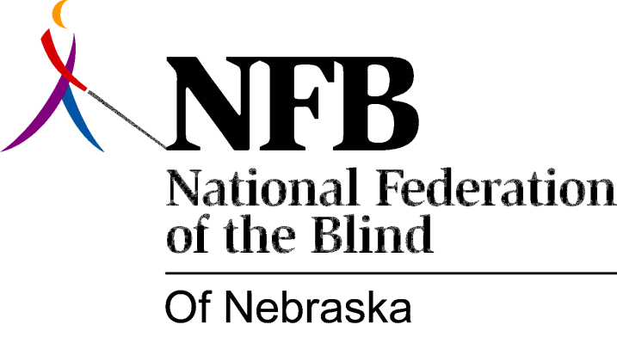

Resolution 2013 – 01
RE: Regarding Apple & Braille

WHEREAS, Apple has been a game-changer in assistive technology since 2009, with the release of its VoiceOver screen reader; and

WHEREAS, Apple has support for a wide array of Braille displays built into iPhones and other devices running the iOS operating system with VoiceOver; and

WHEREAS, Apple’s Braille support has made input of contracted Braille difficult from its inception, due to inappropriate translation when a letter that can be used as a Braille contraction is entered before a pause in keyboard activity, thereby incorporating the expanded word rather than the single letter into a word; and

WHEREAS, these errors require users either to write in uncontracted Braille or to use other work-arounds such as inserting a letter sign (dots 5-6) before a letter that can be used as a contraction in case a pause in keyboard activity occurs to let the system know it is not to be translated; and

WHEREAS, there are numerous other cumbersome work-arounds that don’t fit the “it’s intuitive and it just works” test that has been the hallmark of Apple products including VoiceOver; and

WHEREAS, Apple products are frequently paired with Braille displays for use as note taking devices in schools, rehabilitation and other educational settings; and

WHEREAS, teachers, rehabilitation professionals and student services officials responsible for providing reasonable accommodations for students and clients are often unaware of the impact of this poor Braille support on students; and

WHEREAS, Apple has shown its commitment to accessibility through such added tangible enhancements as alternative forms of input and innovative ways to use the camera; and

WHEREAS, it is crucial that Apple put the same effort into implementing the changes necessary to fix the inconsistent way it supports Braille input from Braille displays as it has into these innovations, because there is living proof that Braille is a blind person’s ticket to higher education and a greater chance of gainful employment: Now, therefore,

BE IT RESOLVED by the National Federation of the Blind of Nebraska in Convention assembled this twenty-seventh day of October, 2013, in the city of North Platte, Nebraska, that this organization encourage Apple to fix its Braille input support to promote proper writing in literary Braille; and

BE IT FURTHER RESOLVED that this organization urge teachers, rehabilitation professionals and student services officials to use due diligence when providing equipment to students, including interacting with our organization to put them in touch with blind users with first-hand experience with the problems students face with taking good Braille notes on an Apple product running the iOS operating system with VoiceOver connected to a Bluetooth Braille display and the inappropriate writing habits that will be reinforced; and

BE IT FURTHER RESOLVED that we urge parents to do likewise, so they can request note taking alternatives that support good Braille writing skills for their children.

