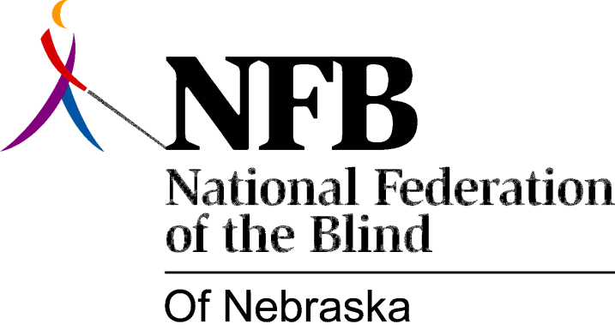

Resolution 2013 – 02
RE: Regarding Educational Technology

WHEREAS, the current level of unemployment among the blind is close to 75%; and

WHEREAS, in today’s society, a post-secondary degree from an institution of higher education greatly enhances a person’s chances of obtaining employment; and

WHEREAS, the right to full and equal participation in the steps necessary to obtain a degree is guaranteed by federal law; and

WHEREAS, technology is becoming an ever-increasing necessity in the classroom of today for a wide range of tasks including, but not limited to, submitting assignments, taking tests, viewing grades, and accessing information supplemental to lectures; and

WHEREAS, blind students, when the technology is correctly developed and programmed, can have equivalent access to the same products used by their peers; and

WHEREAS, recent purchases of new educational technologies by the University of Nebraska Lincoln, such as Camtasia Relay and the Starfish Retention Suite, were initially deployed to students with major accessibility defects that prevented blind students from utilizing systems required both in their classes and in engaging with advisors and faculty: Now, therefore,

BE IT RESOLVED by the National Federation of the Blind of Nebraska in Convention assembled this twenty-seventh day of October, 2013, in the city of North Platte, Nebraska, that this organization strongly encourage the University of Nebraska system to develop and disseminate to its subordinate universities regulations to be followed when obtaining educational technologies, requiring that such technologies comply with accessibility regulations including Section 508 of the Rehabilitation Act of 1973 as amended and, where appropriate, the Worldwide Web Consortium Web Content Accessibility Guidelines version 2; and

BE IT FURTHER RESOLVED that this organization urge the University of Nebraska system to work with us in the development of these regulations, engaging in discussions including, but not limited to, the following topics: inclusion of blind people on committees or other decision-making bodies charged with making educational technology purchasing decisions so that these persons can provide hands-on feedback speaking to the state of the product’s accessibility with the use of screen access technologies, consideration of purchasing guidelines that require manufacturers to provide proof of accessibility in the form of Voluntary Product Accessibility Templates or other similar documentation describing not only elements of the technology that are accessible but also those that aren’t during the product evaluation phase, and implementation of the practice of requiring that accessible technology is purchased when a conflict exists between accessible and inaccessible technology products or software, thereby ensuring that the University system remains in compliance with the above-referenced laws and guidelines.

