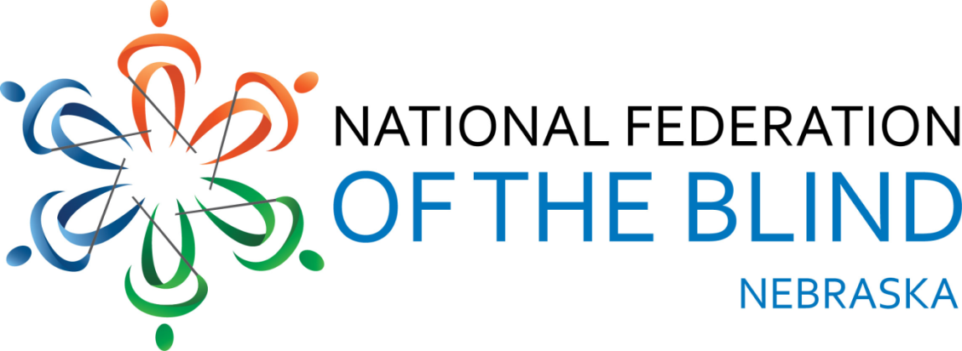

Resolution 2014 – 01
RE: Regarding Nebraska State Historical Society Exhibits at Fort Robinson

WHEREAS, the Nebraska State Historical Society has museums and exhibits of historical events and sites across Nebraska, including Fort Robinson; and
WHEREAS, the Historical society has placed all exhibits at Fort Robinson behind ropes and glass with no models or items that can be touched by visitors; and
WHEREAS, signage for exhibits has poor contrast and is difficult to read with no nonvisual alternative; and
WHEREAS, an interpreter is only there for a short time 5 days a week to assist visitors with understanding the displays; and
WHEREAS, the video about the Cheyenne Indians is also not audio described for blind viewers; and
WHEREAS, Homestead National Monument of America, Sheldon Art Gallery and other museums in Nebraska have made great strides toward including blind visitors by making accessible signage and displays that can be heard, smelled, felt and enjoyed non-visually; and
WHEREAS, the National Federation of the Blind of Nebraska has played an active role in helping these museums to create an experience that is beneficial to everyone including the blind: Now, therefore,
BE IT RESOLVED by the National Federation of the Blind of Nebraska in Convention assembled this twelfth day of October, 2014, in the city of Omaha, Nebraska that this organization call upon the Nebraska State Historical Society to work with us to make its displays and exhibits accessible to blind people, thereby offering the kinds of educational and meaningful experiences its facilities afford other visitors.

