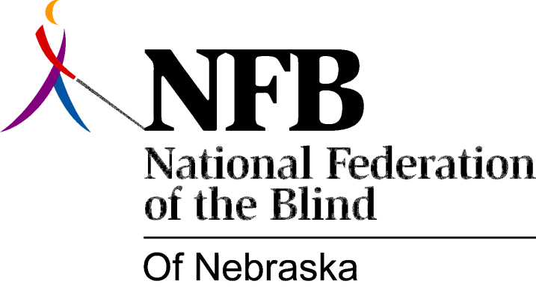

Resolution 1974 - 05
Re: Commend the Attitude of James Nyman, Director Nebraska Services for the Visually Impaired

We the National Federation of the Blind of Nebraska in convention assembled this 18th day of May 1974 in the city of Lincoln do here by

RESOLVE, that after listening to a presentation given by the new director of Vocational Rehabilitation State Services for the Visually Impaired Dr. James Nyman that we have determined his willingness to work with and co-operate with not only the Federation but any and all blind individuals or groups and to provide a hand and hand working relationship with these groups or individuals to insure the best possible rehabilitation and services to the blind and Visually Impaired, and,

WHEREAS, we have determined this positive attitude and his willingness to work with the blind we the National Federation of the Blind of Nebraska do herby lend our support to and willingness to work with the new director so long as the President and the State Board determines it is in the best interest of the blind of Nebraska or until such time a convention determines otherwise.

