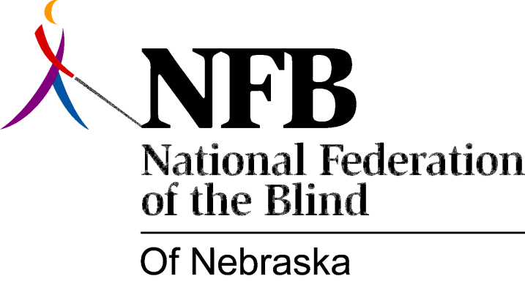

Resolution 1976 – 07
Re: Nebraska State Employment of the Blind

WHEREAS, there are a multitude of job opportunities in Nebraska State Offices, Agencies, and Departments, and,

WHEREAS, there are many blind Nebraskans qualified to work at all levels of employment within the various state offices, agencies, and departments, and,

WHEREAS, many blind Nebraskans are unemployed or under-employed, and,

WHEREAS, section 20-126 of the Nebraska State Statutes states that: “it is the policy of this state to encourage the blind, the visually handicapped and, the otherwise physically disabled to participate fully in the social and economic life of the state and to engage in remunerative employment”, and,

WHEREAS, recent revisions of State employment applications have eliminated many discriminatory questions but have not eliminated questions in regard to physical impairments; now, therefore,

BE IT RESOLVED, by the National Federation of the Blind of Nebraska, in convention assembled this 15th day of May, 1976, in the city of Grand Island, Nebraska, that a committee be established to study the status of the Blind in Nebraska state employment, and,

BE IT FURTHER RESOLVED, that this committee work toward the elimination of questions on state employment applications in regard to physical impairments, and,

BE IT FURTHER RESOLVED, that this committee submit a report of its findings and recommendations to the National Federation of the Blind State Board and to the National Federation of the Blind of Nebraska Convention in 1977.

This Resolution Passed Unanimously.

