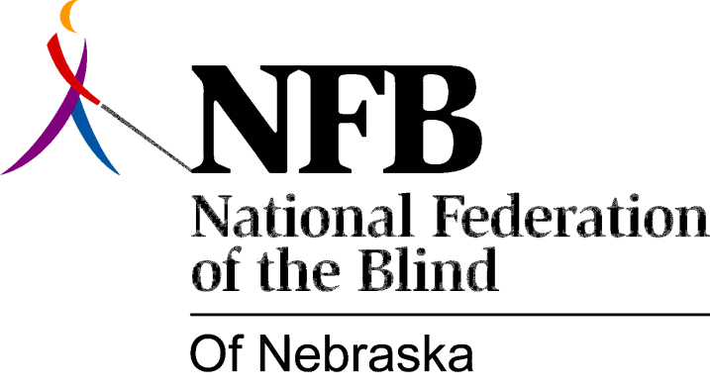

Resolution 1976 – 08
Re: Discrimination of Blind Teachers in Nebraska

WHEREAS, the blind have amply demonstrated their ability to successfully teach in public schools, at all grade levels – kindergarten through college, and,

WHEREAS, there is evidence that blind teachers of Nebraska have encountered prejudice and discrimination in their attempts to seek or retain employment as licensed teachers with Nebraska schools, now, therefore,

BE IT RESOLVED, by the National Federation of the Blind of Nebraska, in convention assembled this 16th day of May, 1976, in the city of Grand Island, Nebraska, that a committee be established to study the status of the employment of blind teachers in Nebraska, and,

BE IT FURTHER RESOLVED, that this committee submit its findings and recommendations to the National Federation of the Blind State Board, and the 1977 National Federation of the Blind of Nebraska State Convention.

This Resolution Passed Unanimously.

