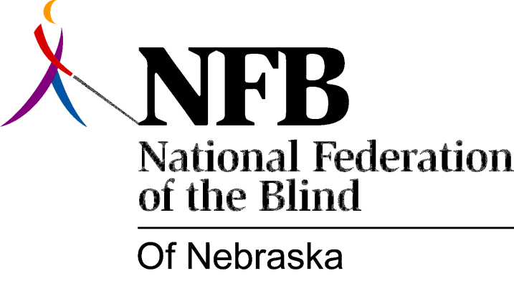

Resolution 1977-04
Re: Creation of a Standing Public Relations Committee

WHEREAS, Every member of the National Federation of the Blind of Nebraska is Responsible for explaining the goals and philosophy of the National Federation of the Blind to the general public and current members who may not fully understand; AND

Whereas, Although the foregoing is true some organization has to be given to the effort of informing the public of the aforementioned goals and philosophy; NOW, THEREFORE,

BE IT RESOLVED by the National Federation of the Blind of Nebraska in convention assembled this 15th day of May, 1977 in the city of Lincoln, Nebraska, that the president of this organization shall appoint a standing public relations committee whose purposes will be:

1. To coordinate a statewide public relations effort,

2. To cooperate with the membership committee in conducting seminars throughout the state to be open to members and those interested in joining (as well as the general public) for the purpose of discussing the philosophy of the National Federation of the Blind and issues affecting the blind; AND

BE IT FURTHER RESOLVED, That this committee be instructed to work with the current membership and ask for its assistance in the foregoing efforts; AND,

BE IT FURTHER RESOLVED, That the chairman of this committee shall present progress reports at every meeting of the board of directors of the National Federation of the Blind of Nebraska.

Passed Unanimously May 15, 1977

