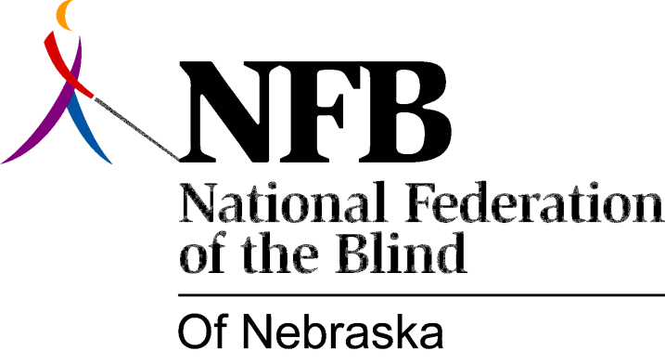

Resolution 1977-05
RE: Creation of a Committee to Study the Commission Structure of an Agency to Serve the Blind.

WHEREAS, The National Federation of the Blind of Nebraska believes that rehabilitation services for the blind must be of the highest caliber possible and must truly serve the needs of the blind as effectively and judiciously as possible; AND,

WHEREAS, There exists outstanding evidence that an independent agency operating under the Commission Structure can best achieve the highest quality of rehabilitation services; AND,

WHEREAS, Nebraska Rehabilitation Services for the Visually Impaired currently operates within the department of public institutions and is further constrained by mandated association with the Nebraska Department of Personnel, the Department of Administrative Services, and other State Agencies and Services AND,

WHERAS, The National Federation of the Blind of Nebraska is Committed to the Concept that the Blind must have an adequate voice in the affairs which affect their lives; NOW, THEREFORE,

BE IT RESOLVED, That the chairman of this committee shall make regular reports to all meetings of the Board of Directors of this organization and shall be responsible to carry out instructions and recommendations of the board of directors

Passed Unanimously May 15, 1977

