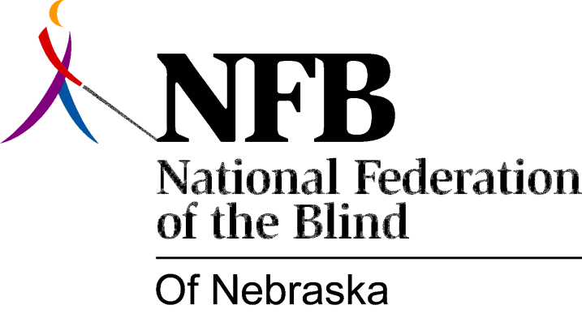

RESOULTION 1977-12
RE: Efforts by this organization to inform blind teachers and training intuitions of the National Federation of the Blind -- Teachers Division

WHEREAS, Blind people wishing to become teachers often do not know of the resources available to them; AND,

WHEREAS, Blind Teachers still face discrimination in hiring; AND,

WHEREAS, The National Federation of the Blind -- Teachers Division has been established to Deal with both of these needs; AND,

WHEREAS, Many blind Nebraska teachers are unaware of the work of the National Federation of the Blind -- Teachers Division; now, therefore,

BE IT RESOLVED, By the National Federation of the Blind of Nebraska in Convention assembled this 15th day of May, 1977, in the city of Lincoln, NEbraska that this organization make every effort to inform blind teachers and teacher training institutions about the National Federation of the Blind -- Teachers Division; AND,
BE IT FURTHER RESOLVED, That the Committee on the Status of Blind Teachers is charged with the responsibility of the implementation of this resolution.

Passed Unanimously May 15, 1977

