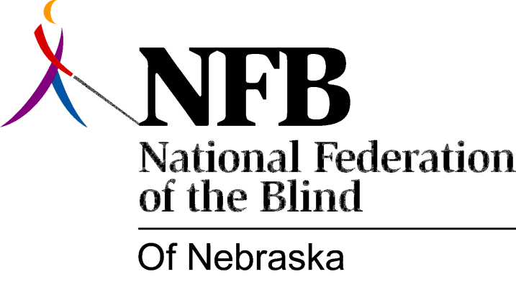

Resolution 1978 – 03
Re: Education of Blind Children—Resource Center

WHEREAS, Public Law 94-142 (the Education of All Handicapped Childrens’ Act) mandates that all blind children be placed in the "least restrictive educational environment" and

WHEREAS, Nebraska Law Section 79-2002 provides that the Nebraska School for the Visually Handicapped "... shall be the state resource center for all educational programs for visually handicapped children in Nebraska and shall provide services such as in service training of teachers, itinerant teaching, counseling services, the loaning of equipment, books and learning media, to local school districts and educational service units" and

WHEREAS, many parents of blind children in Nebraska have experienced unnecessary difficulties in getting the services and equipment (i.e. counseling, brailed and recorded texts, itinerant teachers) necessary to the academic success of their children in the public school setting and

WHEREAS, the Nebraska School for the Visually Handicapped has told parents that their difficulties are a result of lack of funds and staff time to implement these provisions and

WHEREAS, the Nebraska School for the Visually Handicapped does not view public schools as a good and viable alternative to the residential school and therefore, even with adequate funding and staff, would not provide services to public schools in the most positive and constructive manner, now, therefore,

BE IT RESOLVED, by the National Federation of the Blind of Nebraska, in convention assembled this 17th day of June, 1978, in the city of Omaha, Nebraska, that the Education Committee of the National Federation of the Blind of Nebraska evaluate the present structure of providing services to public schools and make recommendations to the National Federation of the Blind of Nebraska Board of Directors.

Passed unanimously, June, 1978.

